**(4/11)Daily Scrum or Standup Meeting**

Team name: 10

Scrum Master: Nick Jugganaikloo

Date: 4/11

|  |  |  |  |
| --- | --- | --- | --- |
| **Team Member** | **What did you do since the last scrum?** | **What do you plan to do before the next scrum?** | **What obstacles do you have?** |
| George Done |  |  |  |
| Zach Hawkes | Worked on getting the email stuff up and running. | Finish email and work on the return movie process | None that I know of yet. |
| Tanner |  | Fix init. Update Lending/Borrowing on home page. Clean up header. | CSS |
| Nick Jugganaikloo | Took a break | Update movie possession when borrow happens. Show success message for borrow requests. | Making it look good. |
|  |  |  |  |

# Burndown

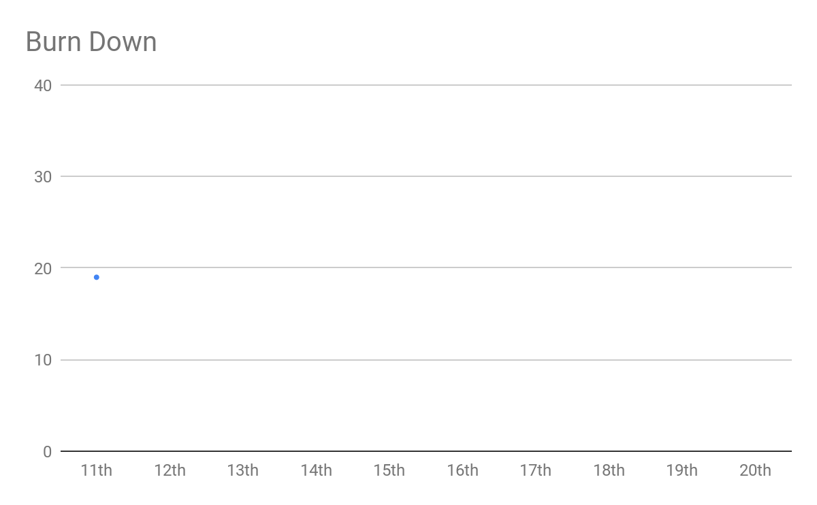

# 

# Screenshot of you task board

